SNOWFLAKE TABLES
Types of tables in snowflake:
- Permanent tables
- Transient tables
- Temporary tables
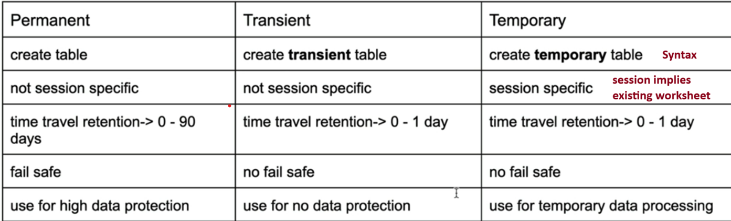
If any terms are not understandable, we will see later

So, in general to manage storage cost efficiently we will use a specific table type as per the requirement

Which table is visible if all three types of table have the same name? If a table named ‘client’ is present as permanent, transient and temporary and I execute ‘select from client’, which table will return the data? Will there be any conflict in names?

Let’s see in practical

Create a table ‘client’
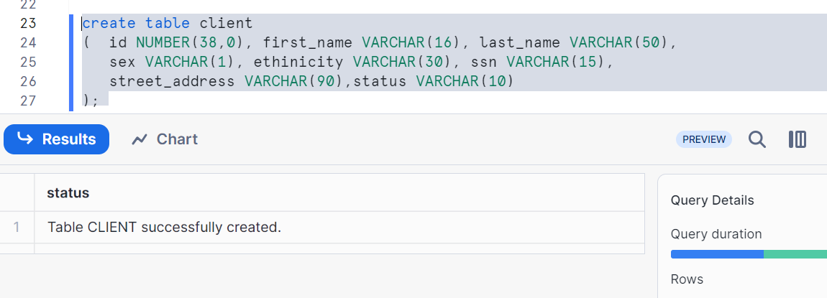
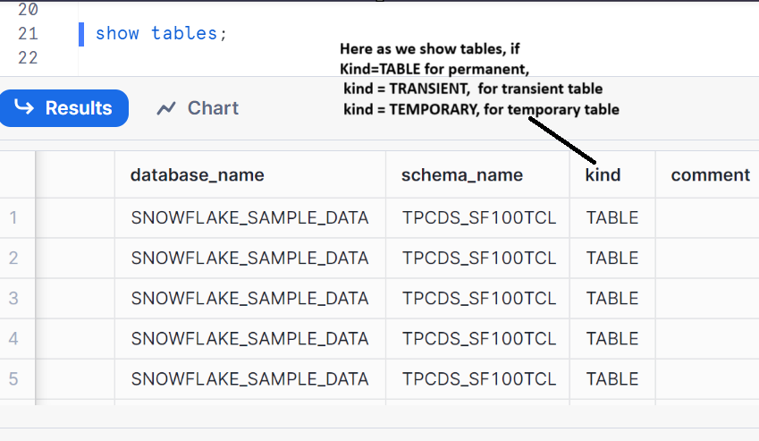
Insert values
insert into client values (111111, 'James', 'Schwartz', 'M', 'American','342-76-9087','5676 Washington Street','ACTIVE') ;
insert into client values (222222, 'Jessica', 'Escobar', 'F', 'Hispanic','456-93-5629','3234 WateringCan Drive','INACTIVE') ;
insert into client values (333333, 'Ben', 'Hardy', 'M', 'American','876-98-3245','6578 Historic Circle','INACTIVE') ;
insert into client values (444444, 'Anjali', 'Singh', 'F', 'Indian American','435-87-6532','8978 Autumn Day Drive','ACTIVE') ;
Insert into client values (555555, 'Dean', 'Tracy', 'M', 'African','767-34-7656','2343 India Street','ACTIVE');
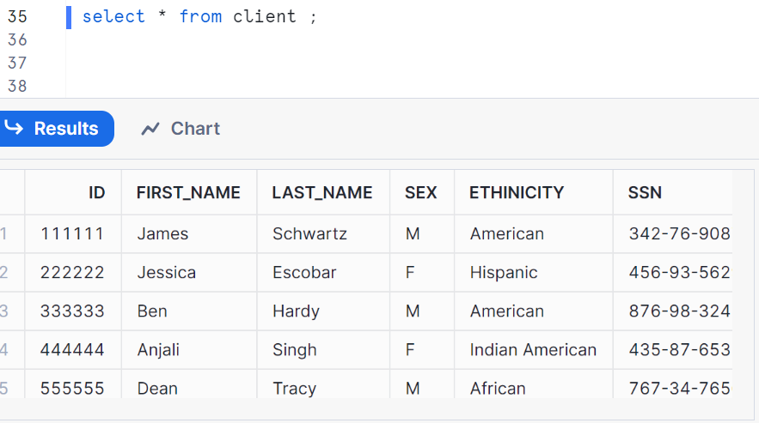
So we created permanent table by default with table name ‘client’
Now let’s create transient table with same name as permanent table what we created as ‘client’
You can see that it can’t create as below image
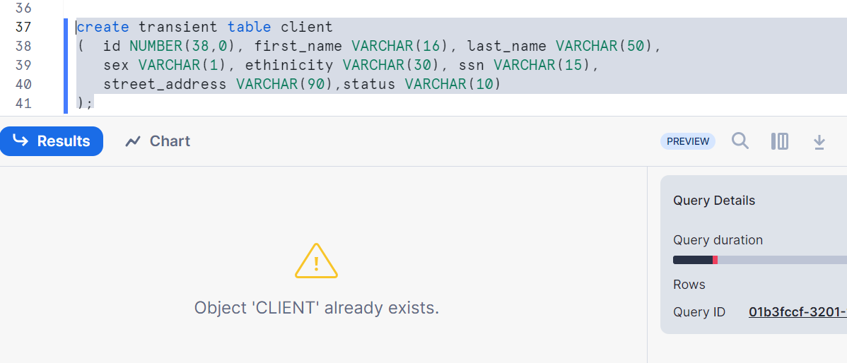

But we can create the temporary table of the same name which will hide the main permanent table ‘client’
Create temporary table client
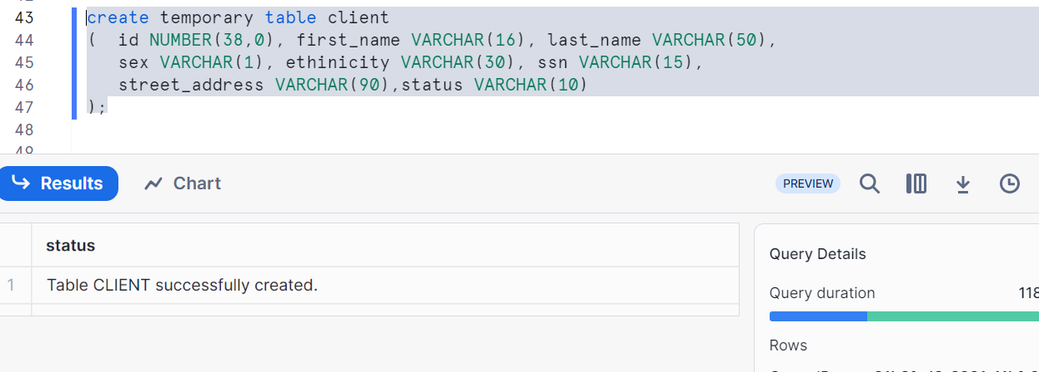
Inserting two rows as shown
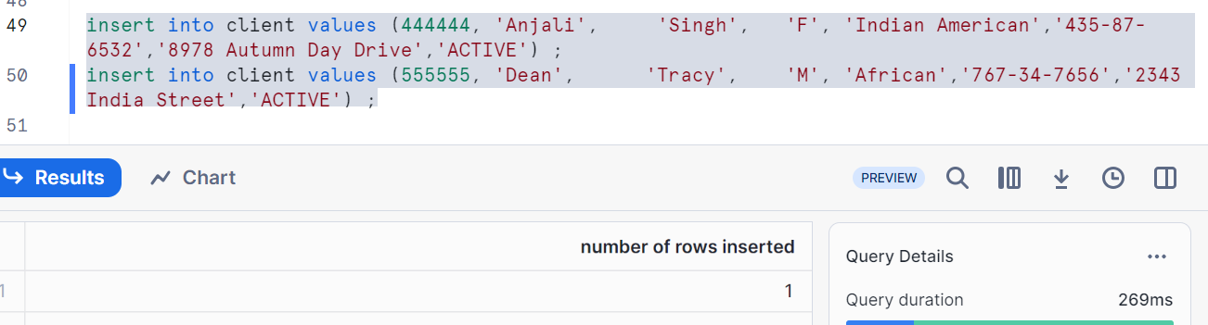
Let’s check the table ‘client’
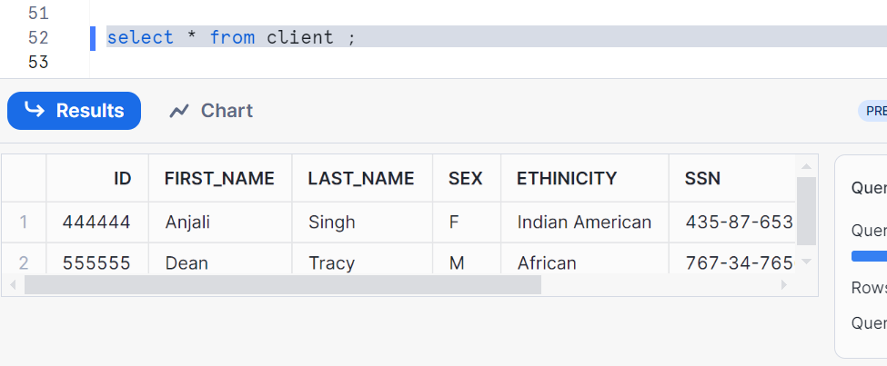
Hence any select or DML operation will go to a temporary table.

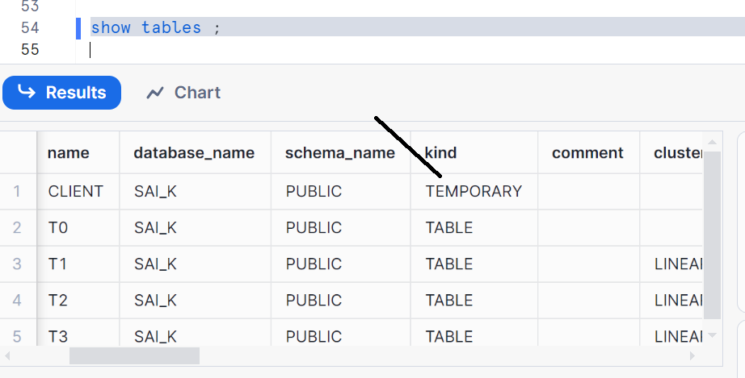

Now if you want to go back and select the data from permanent table we have two ways
- Go to new worksheet
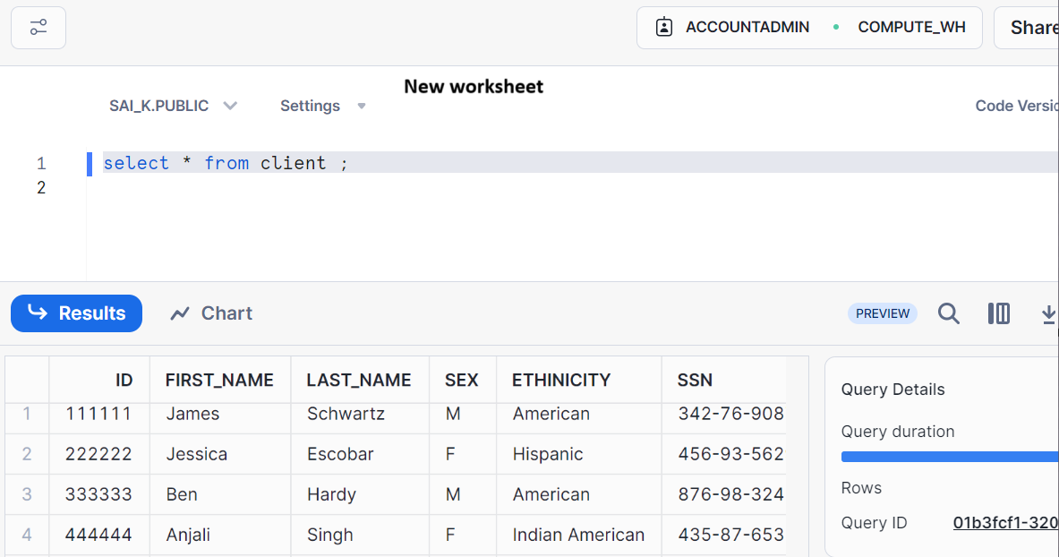
- Drop the table, it will drop the temporary table in existing worksheet not in new worksheet
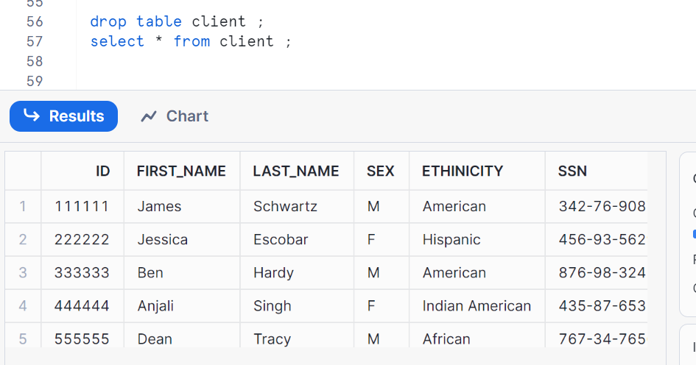
We got the data from permanent table which has 5 records

Now let’s go vice versa
Create a transient table as shown
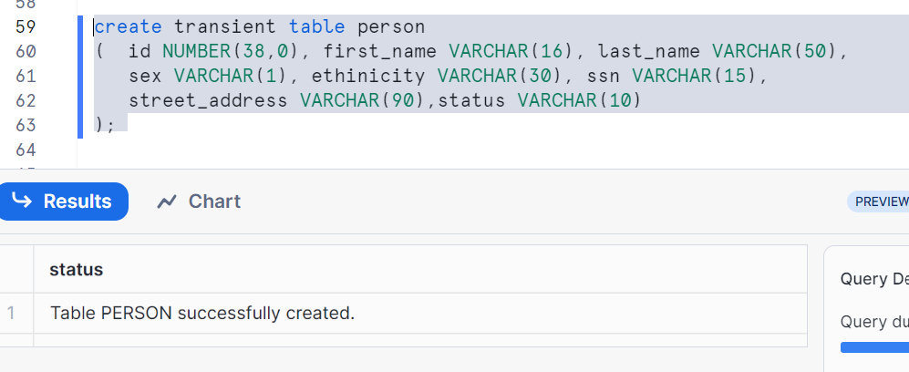

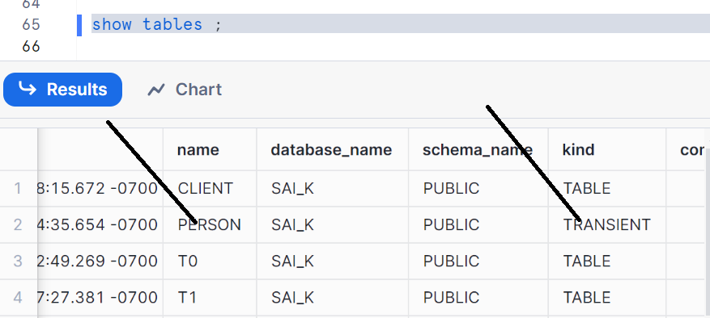
Inserting 5 records
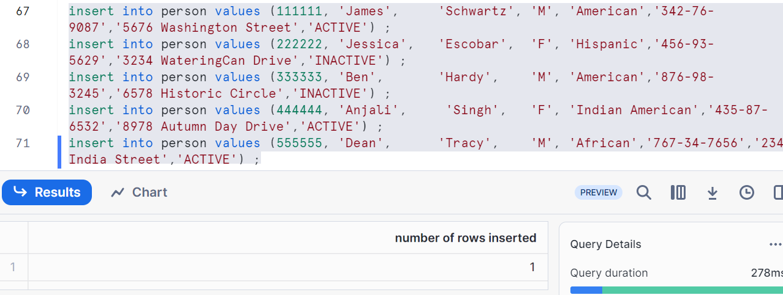
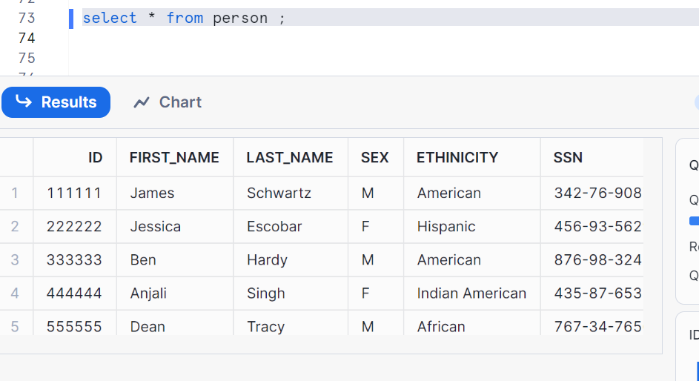
Now as I have a transient table, let’s try to create a permanent table
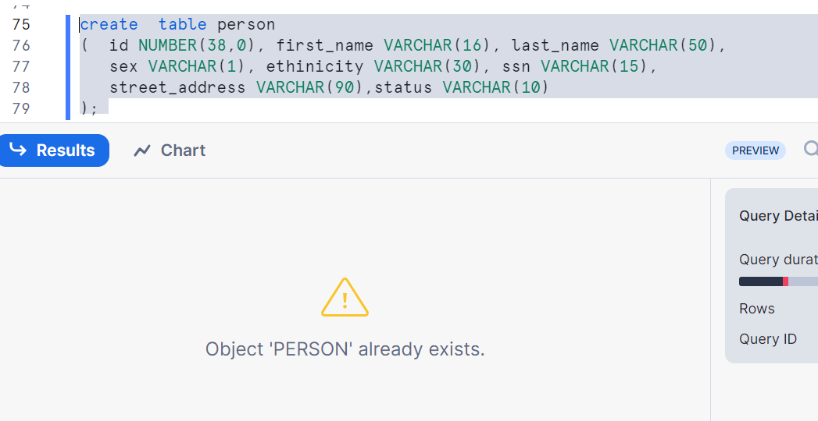
It doesn’t allow me to create
Let’s create a temporary table
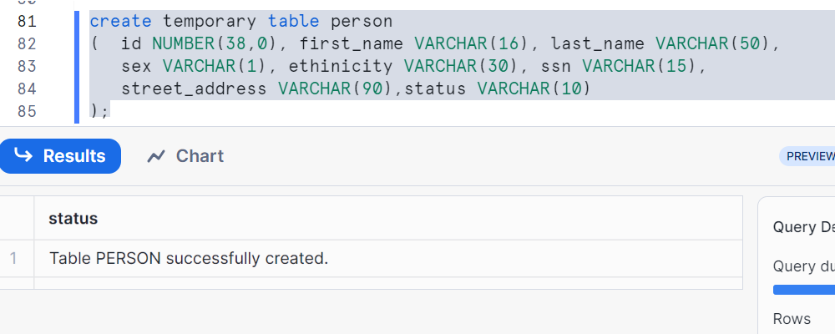
Insert 3 rows
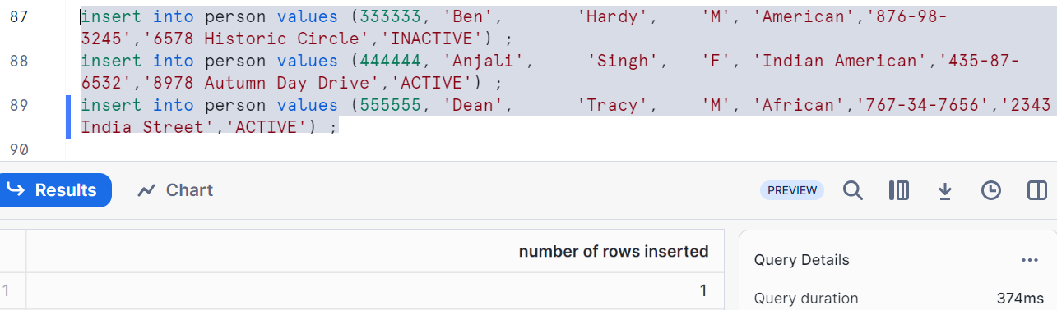
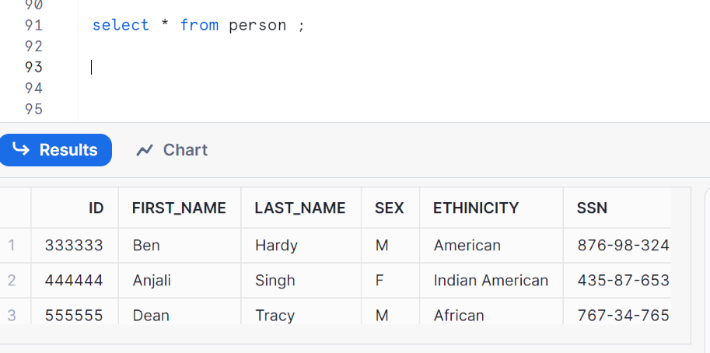
Temporary table hides the main transient table person
Hence any select or DML operation will go to a temporary table. Here we will open a new session and run, it gives you data from permanent table. If you want to move from temporary to transient, drop the table and see the table records again by selecting ‘select * from person’;

Database and schema types
Types of databases
Permanent and transient
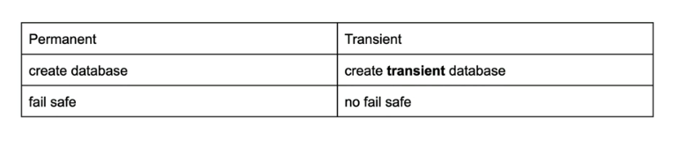
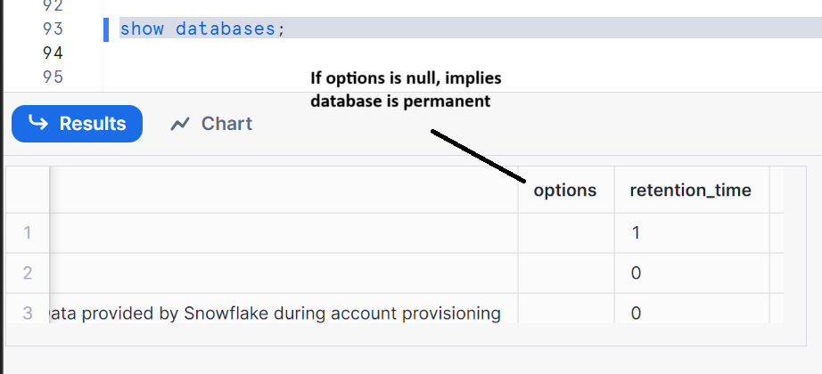

Create a transient database
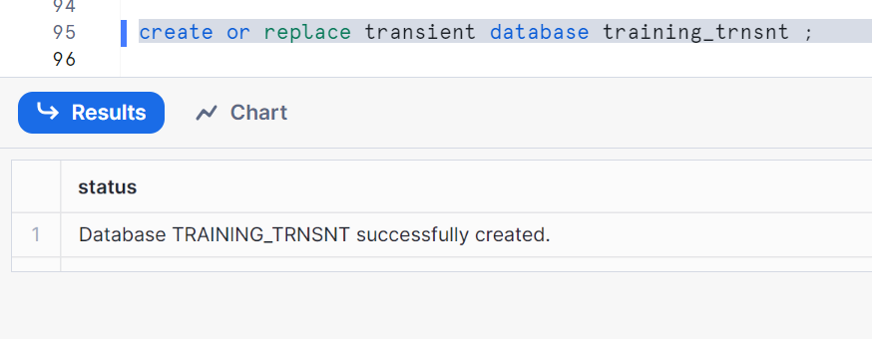
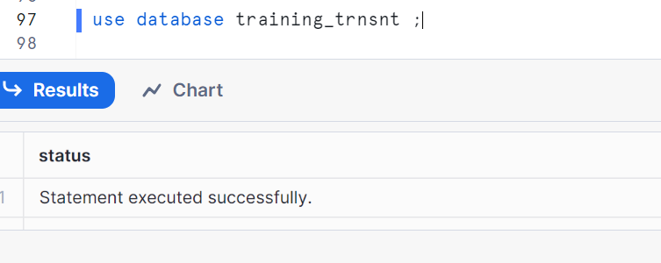
Creating schemas and checking what actual type of schemas are they?
Creating schemas with and without help of keyword ‘transient’
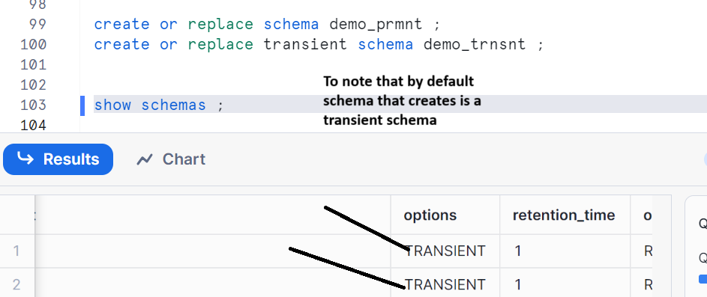
We observed that by default schemas it creates is transient

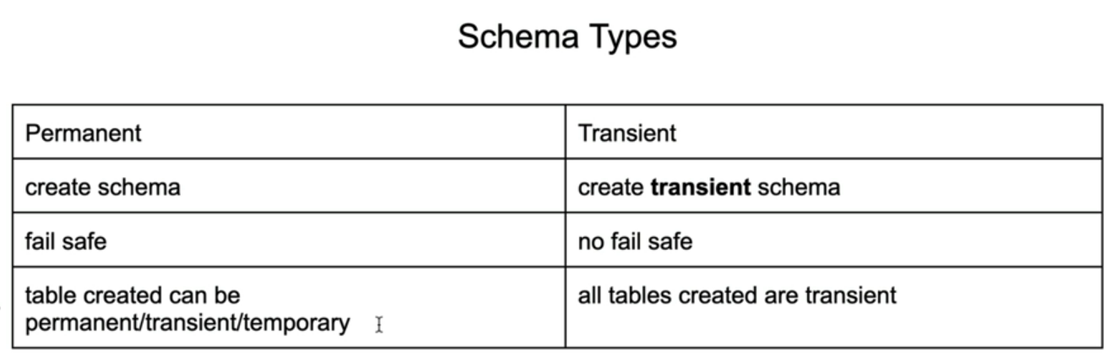
Let’s check in practical.
Let’s use demo_trnst schema (as we had seen which is a transient schema in above)
We tried creating a permanent table ‘client’ but shows transient as below image
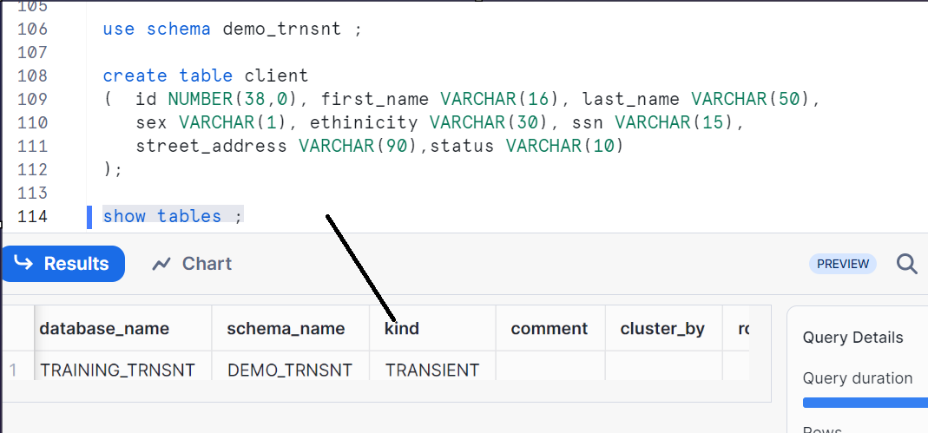

Let’s create temporary tables in transient schema i.e. demo_trnst
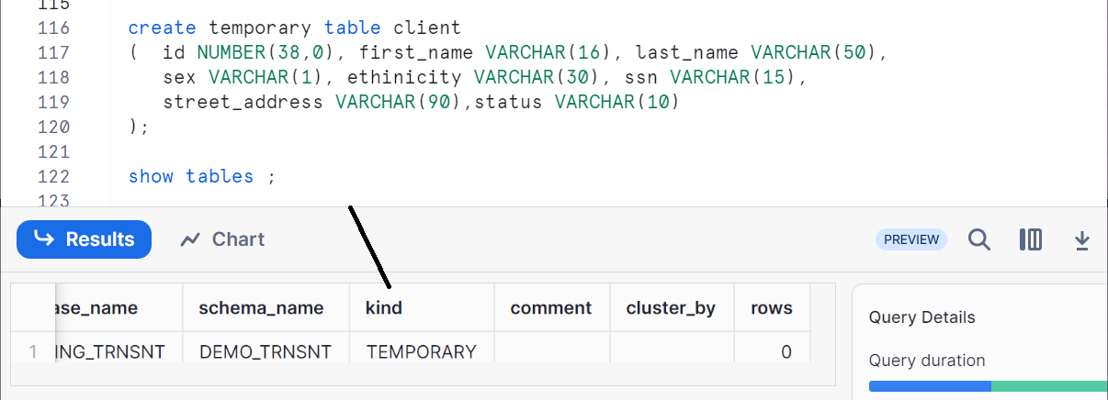

To conclude,
You cannot create a permanent table in a transient schema. Only transient and temporary tables are allowed.

